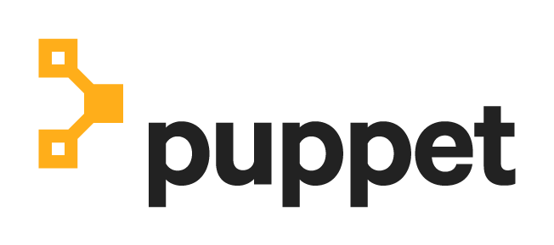

TAM Service Engineer Engagement Check

Puppet Agent Side Infrastructure Assessment Report

*for*

#### 

Acme Corp

**Prepared By**: Adam Shambrook

**Last Revision:** v1.0.0

**Last Revision Date:** February 1, 2022

# Document Summary

This Technical Account Management Service Engineer (TSE) quarterly assessment check report has been prepared after obtaining Puppet Agent diagnostic and log information and focusing on the agent side infrastructure specific items. The Puppet TSE and Solution Architect teams have reviewed your specific environment details against Puppet Best Practices associated with Puppet Enterprise agent side infrastructure.

This report will be presented during a customer advisory session to review the noted findings, suggested Puppet environment changes / updates and other Puppet recommendations. Optionally, your Puppet account team will follow-up with a SOW for a Puppet Professional Services Engineer and/or a Puppet Solutions Architect to implement the recommendations if your team is unable to perform the suggested changes.

# Engagement Check Contacts

|  | **Puppet TAM** | **Puppet TSE** | **Puppet Architect** |
| --- | --- | --- | --- |
| Name: | [Insert TAM Name] | [Insert TSE Name] | [Insert Architect Name] |
| Email: | [Insert TAM Email] | [Insert TSE Email] | [Insert Architect Email] |

# Engagement Check **Summary**

The Puppet Enterprise Agent Side Infrastructure assessment check will review your current Puppet Agent with two (2) tiers of checks:

1. High level estate overview:
   1. Are nodes checking in on the desired run interval, sending reports, and connected to the orchestration broker
   2. Investigation of outliers
   3. Agent version review
2. Check agents on Puppet infrastructure components are mechanically sound:
   1. Agents are reporting regularly
   2. Agents are not running in noop mode
   3. Agents apply the latest catalog and run idempotently between changes

# Recommendations

The following recommendations are suggested based on the performed Agent Side assessment check:

1. PE Agent side infrastructure configuration validation:
   1. Managed Estate - Comparing the node counts for active nodes and nodes with certificates that are not expired, there are 100-150 nodes not checking in on the scheduled period. Is this intentional? Ideally, all nodes should be under declarative enforcement, or the nodes should be purged to free up licensing.
2. Agent side issue:
   1. 53 nodes are checking into the Puppet server using Puppet Agent version ​​5.5.22 while your PE infrastructure, and remaining Puppet agent versions are up to date at 6.25.1. All Puppet agents should be using at least the same major version and ideally all be using the same version.
   2. A subset of agents are set to noop mode - therefore PE is not able to declaratively enforce the desired state configuration. Was this intentional during the period the support script was collected, or is this a long term configuration
3. Best practices for maintaining PE Agents:
   1. Versions - Puppet agents should match the latest supported agent version for your Puppet Primary Server. With your PE code following Puppet best practices, upgrading your agent versions should cause minimal disruption. Your Puppet agent version should never be ahead of the agent version supported by your PE Primary Server version. Your compilers should use the same PE agent version as each other.
   2. Configurations - To use Puppet to declaratively enforce the desired configuration for nodes within your estate, Puppet Agents should not be running in noop mode, they should be regularly enforcing the latest catalog, and the Puppet agent service should be running idempotently between changes.
4. Other Noted Items:
   1. It is recommended to address the missing nodes from your PE environment, and upgrade the legacy agent versions to version 6. These agent versions may not work with future supported versions of PE, and it would be best to prevent these nodes from restricting you from upgrading by proactively updating them soon.